**LAPORAN PRAKTIKUM 2**

**PEMROGRAMAN 4**

**Nama : Moh. Rachmat Wira Utama**

**NPM : 4513210025**

1. Membuat aplikasi project java web menggunakan Maven

Pom.xml

<?xml version="1.0" encoding="UTF-8"?>

<project xmlns="http://maven.apache.org/POM/4.0.0" xmlns:xsi="http://www.w3.org/2001/XMLSchema-instance" xsi:schemaLocation="http://maven.apache.org/POM/4.0.0 http://maven.apache.org/xsd/maven-4.0.0.xsd">

<modelVersion>4.0.0</modelVersion>

<groupId>com.mycompany</groupId>

<artifactId>praktikum-2</artifactId>

<version>1.0-SNAPSHOT</version>

<packaging>war</packaging>

<name>praktikum-2</name>

<properties>

<endorsed.dir>${project.build.directory}/endorsed</endorsed.dir>

<project.build.sourceEncoding>UTF-8</project.build.sourceEncoding>

</properties>

<dependencies>

<dependency>

<groupId>javax</groupId>

<artifactId>javaee-web-api</artifactId>

<version>7.0</version>

<scope>provided</scope>

</dependency>

</dependencies>

<build>

<plugins>

<plugin>

<groupId>org.apache.maven.plugins</groupId>

<artifactId>maven-compiler-plugin</artifactId>

<version>3.1</version>

<configuration>

<source>1.7</source>

<target>1.7</target>

<compilerArguments>

<endorseddirs>${endorsed.dir}</endorseddirs>

</compilerArguments>

</configuration>

</plugin>

<plugin>

<groupId>org.apache.maven.plugins</groupId>

<artifactId>maven-war-plugin</artifactId>

<version>2.3</version>

<configuration>

<failOnMissingWebXml>false</failOnMissingWebXml>

</configuration>

</plugin>

<plugin>

<groupId>org.apache.maven.plugins</groupId>

<artifactId>maven-dependency-plugin</artifactId>

<version>2.6</version>

<executions>

<execution>

<phase>validate</phase>

<goals>

<goal>copy</goal>

</goals>

<configuration>

<outputDirectory>${endorsed.dir}</outputDirectory>

<silent>true</silent>

<artifactItems>

<artifactItem>

<groupId>javax</groupId>

<artifactId>javaee-endorsed-api</artifactId>

<version>7.0</version>

<type>jar</type>

</artifactItem>

</artifactItems>

</configuration>

</execution>

</executions>

</plugin>

</plugins>

</build>

</project>

Index.html

<!DOCTYPE html>

<html>

<head>

<title>Start Page</title>

<meta http-equiv="Content-Type" content="text/html; charset=UTF-8">

</head>

<body>

<h1>Praktikum 2</h1>

</body>

</html>

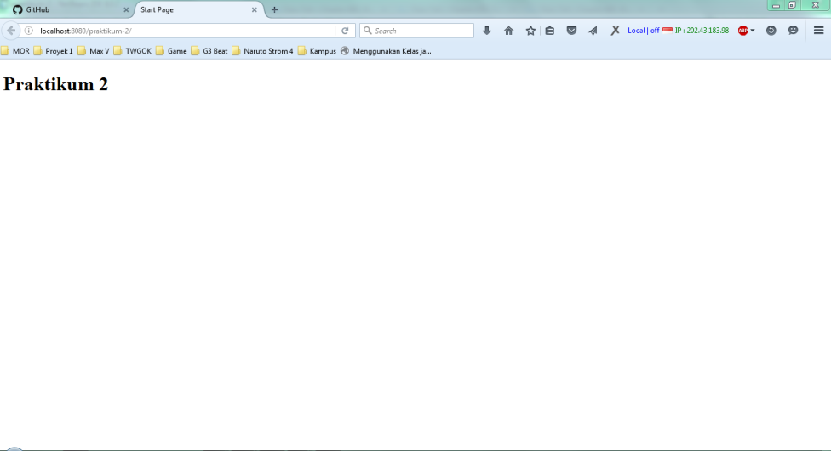

1. Membuat Menampilkan Tanggal Dan Waktu

Source Code

<%@page import="java.sql.Time"%>

<%@page import="java.util.*"%>

<%@page contentType="text/html" pageEncoding="UTF-8"%>

<%@ page import="javax.servlet.*,java.text.*" %>

<%@ taglib prefix="x" uri="http://java.sun.com/jsp/jstl/xml" %>

<%@ taglib prefix="fn" uri="http://java.sun.com/jsp/jstl/functions" %>

<%@ taglib prefix="sql" uri="http://java.sun.com/jstl/sql_rt" %>

<%@ taglib prefix="c" uri="http://java.sun.com/jstl/core_rt" %>

<!DOCTYPE HTML PUBLIC "-//W3C//DTD HTML 4.01 Transitional//EN"

"http://www.w3.org/TR/html4/loose.dtd">

<html>

<head>

<title>Praktikum 2</title>

</head>

<center>

<h1>Tanggal dan Waktu</h1>

</center>

<%

Date dNow = new Date( );

SimpleDateFormat dt = new SimpleDateFormat ("E, dd-MM-yyyy ");

SimpleDateFormat ft = new SimpleDateFormat ("hh:mm:ss");

out.print( "<h2 align=\"center\">Hari dan tanggal saat ini : " + dt.format(dNow) + "</h2>");

out.print( "<h2 align=\"center\">Waktu saat ini : " + ft.format(dNow) + "</h2>");

%>

</html>

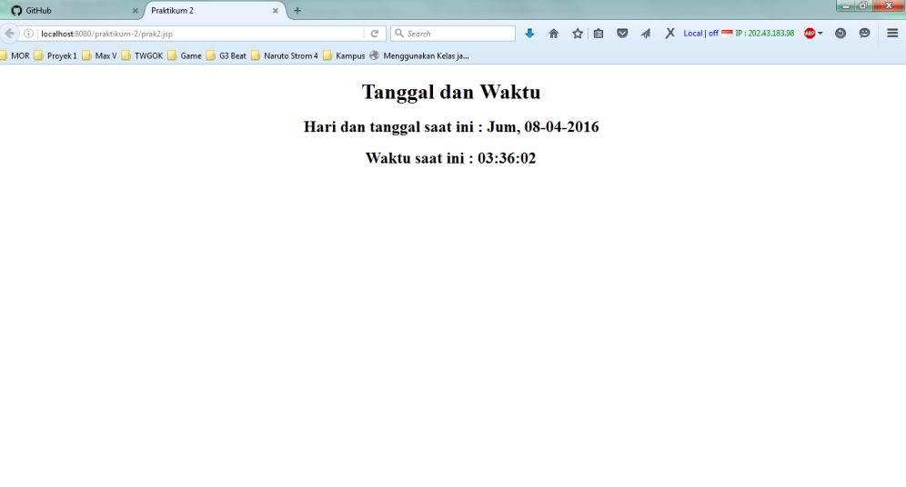

1. Membuat Form Input Data

Source Code

<!DOCTYPE html>

<html>

<head>

<title>Form</title>

<meta charset="windows-1252">

<meta name="viewport" content="width=device-width, initial-scale=1.0">

<meta http-equiv="Content-Type" content="text/html; charset=UTF-8">

</head>

<body>

<center>

<h1>Input Data</h1>

<form action="form" method="POST">

<table border='0'>

<tr>

<td>Nama</td>

<td>: <input name="nama" type="text" /></td>

</tr>

<td>Email</td>

<td>: <input name="email" type="text" /></td>

</tr>

<td>Tanggal Lahir</td>

<td>: <input name="tanggal_lahir" type="text" /></td>

</tr>

<td>Alamat</td>

<td>: <input name="alamat" type="text" /></td>

</tr>

<tr>

<td><input type="submit" name="send" value="Simpan" /></td>

<td><input type="reset" name="reset" value="Reset" />

</tr>

</table>

</center>

</form>

</body>

</html>

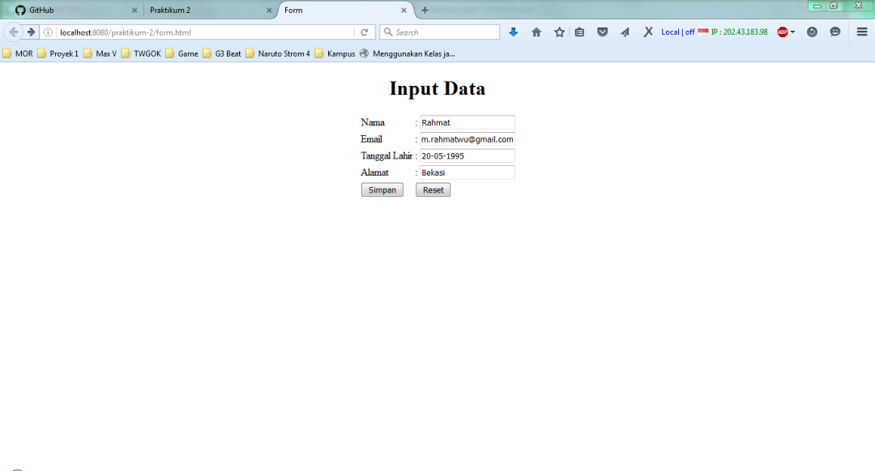

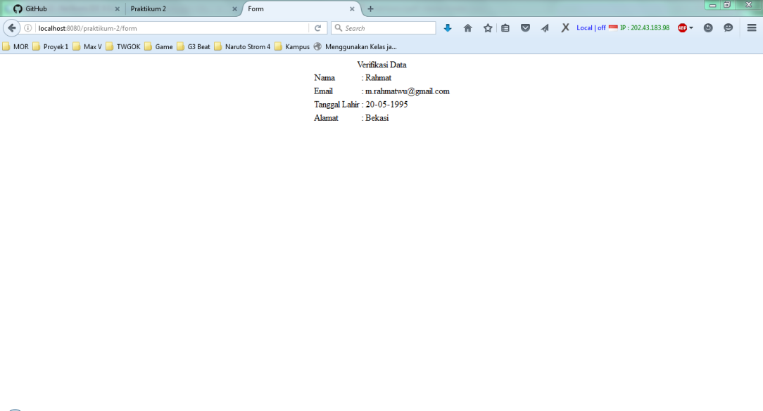

1. Menampilkan Tabel

Source Code

<%@page import="java.sql.Time"%>

<%@page import="java.util.*"%>

<%@page contentType="text/html" pageEncoding="UTF-8"%>

<%@ page import="javax.servlet.*,java.text.*" %>

<%@ taglib prefix="x" uri="http://java.sun.com/jsp/jstl/xml" %>

<%@ taglib prefix="fn" uri="http://java.sun.com/jsp/jstl/functions" %>

<%@ taglib prefix="sql" uri="http://java.sun.com/jstl/sql_rt" %>

<%@ taglib prefix="c" uri="http://java.sun.com/jstl/core_rt" %>

<!DOCTYPE HTML PUBLIC "-//W3C//DTD HTML 4.01 Transitional//EN"

"http://www.w3.org/TR/html4/loose.dtd">

<html>

<head>

<title>Praktikum 2</title>

</head>

<center>

<h1>Tanggal dan Waktu</h1>

</center>

<%

Date dNow = new Date( );

SimpleDateFormat dt = new SimpleDateFormat ("E, dd-MM-yyyy ");

SimpleDateFormat ft = new SimpleDateFormat ("hh:mm:ss");

out.print( "<h2 align=\"center\">Hari dan tanggal saat ini : " + dt.format(dNow) + "</h2>");

out.print( "<h2 align=\"center\">Waktu saat ini : " + ft.format(dNow) + "</h2>");

%>

<h2>DAFTAR PRODUK</h2>

<sql:setDataSource var="snapshot"

driver="com.mysql.jdbc.Driver"

url="jdbc:mysql://localhost/latihan_prak2p4"

user="root" password=""/>

<sql:query dataSource="${snapshot}" var="result">

SELECT * FROM produk

</sql:query>

<table border="1" width="100%">

<tr>

<th>ID</th>

<th>Kode</th>

<th>Nama</th>

<th>Harga</th>

<th>Teakhir Update</th>

</tr>

<c:forEach var="row" items="${result.rows}">

<tr>

<td><c:out value="${row.id}"/></td>

<td><c:out value="${row.kode}"/></td>

<td><c:out value="${row.nama}"/></td>

<td>Rp. <c:out value="${row.harga}"/></td>

<td><c:out value="${row.terakhir_update}"/></td>

</tr>

</c:forEach>

</table>

</html>

